Cite this article as: Drive System Technique, 2025, 39(X), XX–XX
RESEARCH PAPER

The title of sample manuscript (Font Franklin Gothic Medium, Word size 20, Bold)

Author1^{1,2}, Author2^{1,2,}*, Author3³ (Font Arial, Word size 11, Bold)

¹Address1, postcode 124678; (Arial, 8, eg. ¹School of Mechanical Engineering, Shanghai Jiao Tong University , Shanghai 200240, China)
²Address2, postcode 123653; (eg. ²SAIC Motor R&DInnovation Headquarters , Shanghai 201206, China)
³Address3, postcode 123632 (eg. ³North University of China, Taiyuan 030051, China)

Abstract: This is the abstract of sample manuscript. This is the abstract of sample manuscript. This is the abstract of sample manuscript. This is the abstract of sample manuscript. This is the abstract of sample manuscript. A concise summary for the manuscript should be given. Avoid the use of abbreviations in abstracts. (Times New Roman, 8.5)
Keywords: key word1; key word2; key word3 (List 3∼6 keyword, Font Times New Roman, Word size 8.5, the first letter of the first word of each keyword should be lowercase.)

This is the introduction. This introduction is untitled. It should briefly outline the history and current status of related research both domestically and internationally, citing representative references, especially recent developments from the past two years. The study's purpose, problems to be addressed, and methods employed should also be stated. (Font Times New Roman, Word size 9.5, Set the minimum line space of text to 13 pounds)

1 Title (Level 1, Font Franklin Gothic Medium, Word size 11, Bold, Leave a blank line between Titles and text. eg. Experimental)

This is main content of the sample manuscript. This is main content of the sample manuscript. (Font Times New Roman, Word size 9.5, Set the minimum line space of text to 13 pounds)

1.1 Title (Level 2, Franklin Gothic Medium, 11, Bold)

All physical quantities, units of measurements should be expressed in the international system of units (SI). Other quantities should be converted into SI units.
Physical quantities (Italic type): c (concentration), p (pressure), t (temperature or time), T (temperature), s (selectivity), x (conversion), δ (chemical shift), m/m (mass ratio), n/n (molar ratio), w (mass fraction), φ (volume fraction).
Units (Roman type): s (seconds), min (minutes), h (hours), d (days), mol/L (concentration), Pa (pressure), nm (length), r/min (speed).
Using ppm, ppb, etc., to indicate substance content lacks precision, it should be expressed as w (mass fraction), ϕ (volume fraction), x (molar fraction), or g/mL (mass concentration). Temperature units should be presented as either °C or K in the same paper. (Times New Roman, 9.5)

1.2 Title (Level 2, Franklin Gothic Medium, 9.5, Bold)

All figures and tables should be placed in the text near the point of the first mention. The same data should not be presented in more than one figure or in both a figure and a table. Charts should be avoided when the data can be adequately described in words (such as only 3∼5 data). The captions should be understandable without reference to the text. Precautions are as follows:
(1) The main experimental conditions should be given.
(2) Each abbreviation must be defined the first time it is used in manuscript and again in figures and tables.
(3) Figures and tables should be positioned at the top or bottom of each manuscript page.
(4) All figures can be edited by Origin.
(5) Original and high-resolution photographs (separate JPEG graphics file) should be submitted.
(6) Leave a blank line between the figures (or tables) and the text.
(7) Sample figure as shown in Figure 1.
(8) Tables should be created in three-line form, as shown in Table 1.

2 Title (Level 1, Franklin Gothic Medium, 11, Bold, eg. Results and discussion)

All formulas must be inserted or edited in Microsoft Word using the Times New Roman, as illustrated in Equation (1).
$$\text{ln}\text{k} \text{=} \text{ln}\text{A} \text{–} \frac{{\text{E}}_{\text{a}}}{\text{RT}} \text{(1)}$$
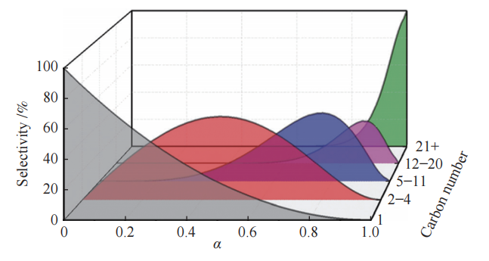
Fig. 1 ASF model of Fischer-Tropsch synthesis
(Times New Roman, 8.5)

Table 1 Pore characteristics of solid products varying with heating temperature (Times New Roman, 8.5)
Sample | BET surface area S/(m²·g⁻¹) | Total pore volume v/(cm³·g⁻¹) (Times New Roman, 7.5) | Average pore size d/nm
HB400 | − | − | −
HB500 | 4.5983 | 0.002320 | 2.0179
HB600 | 14.5326 | 0.003612 | 0.9242
MS400 | 2.3882 | 0.004051 | 6.7856
MS500 | 7.4815 | 0.007779 | 4.1592
MS600 | 58.4711 | 0.030234 | 2.0683

3 Title (Level 1, Franklin Gothic Medium, 11, Bold, eg. Conclusion)

This is conclusion of the sample manuscript. This is conclusion of the sample manuscript. This is conclusion of the sample manuscript.

Declaration of Competing Interest

The authors declare no conflict of interest.

References

- Ni Y, Liu Y, Chen Z, et al. Realizing and recognizing syngas-to-olefins reaction via a dual-Bed catalyst. ACS Catal, 2019, 9(2): 1026−1032. (periodical, Times New Roman, 8.5)
- Levenspiel O. Chemical Reaction Engineering. New Delhi: Wiley Eastern, 1974: 368−371. (book, Times New Roman, 8.5)
- Zhao Z, Tang L, Ma X. Biomass pyrolysis in an argon/hydrogen plasma reactor//Processings of 10th China Plasma Science & Technology Conference and Youth Forum on Plasma Science & Technology. Changsha: National Defence Science & Technology University Press, 2001: 156−159. (multi-author books with editors or proceedings, Times New Roman, 8.5)
- Haag W O, Olson D H, Rodewald P G. Hydrogen regeneration of coke-selectivated crystalline aluminosilicate catalyst: US, 4358395. 1982−11−09. patent (patent, Times New Roman, 8.5)
- Yan S. Supercritical-phase Fischer-Tropsch synthesis for producing heavy hydrocarbons. Taiyuan, China: Institute of Coal Chemistry, Chinese Academy of Sciences, 1997. (thesis, Times New Roman, 8.5)

